How to change root password:
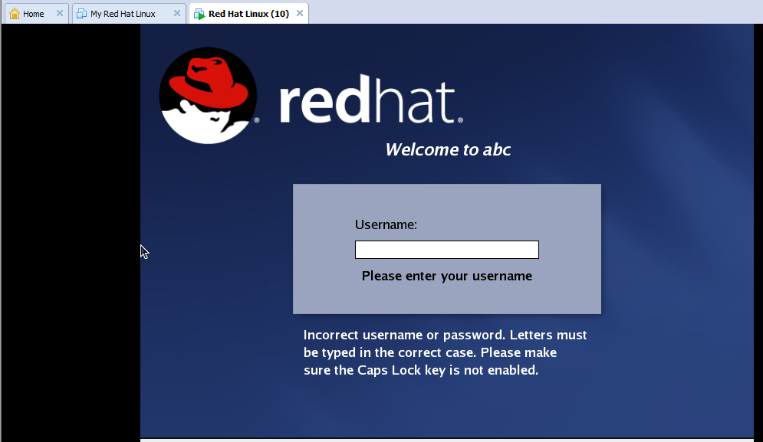
- Open Vmware, select redhat linux from left pane and click on power on this virtual machine.
- When the following screen appears immediately press ctrl+g and then e
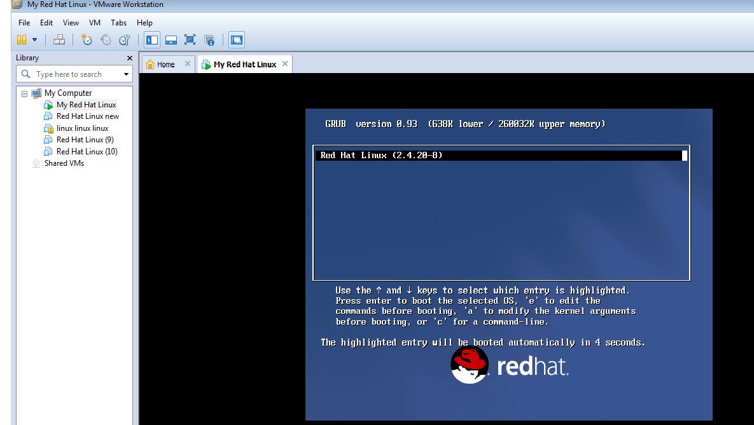

- After this the following screen appears and select second option with arrow key and press e.
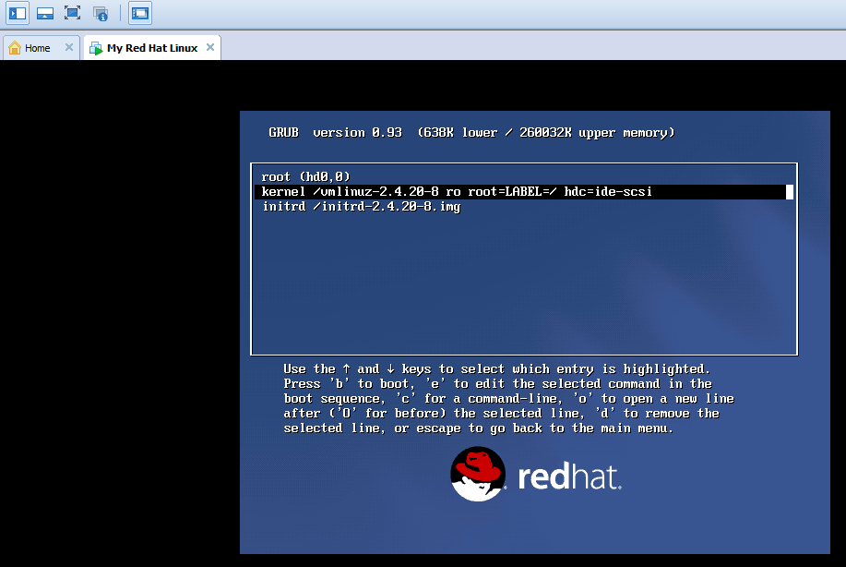

- Following screen will appear and after scsi, you have to press space and then type 1 and press enter.
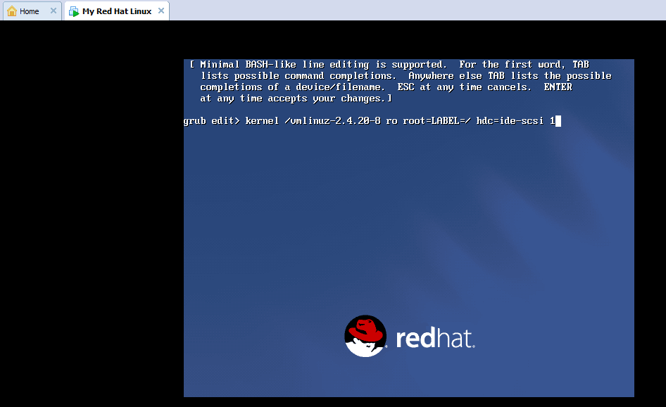
- After this following screen appears. Now press b.
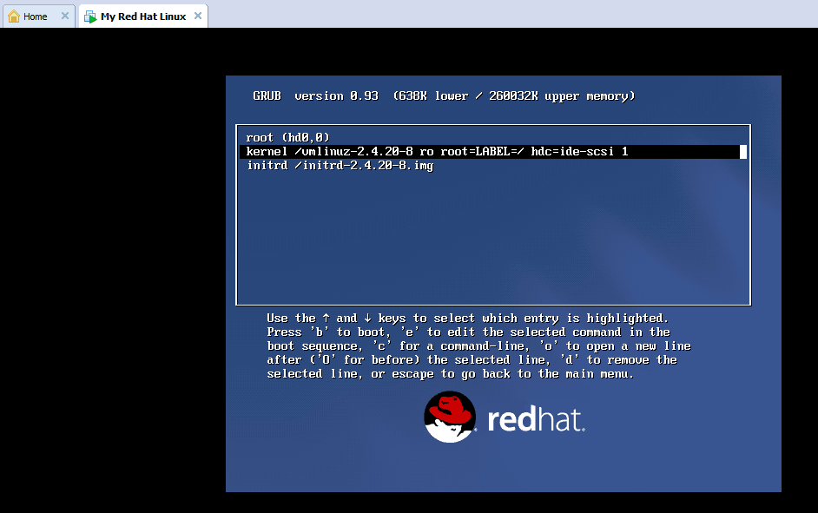

- Whenever following screen appears type passwd.
